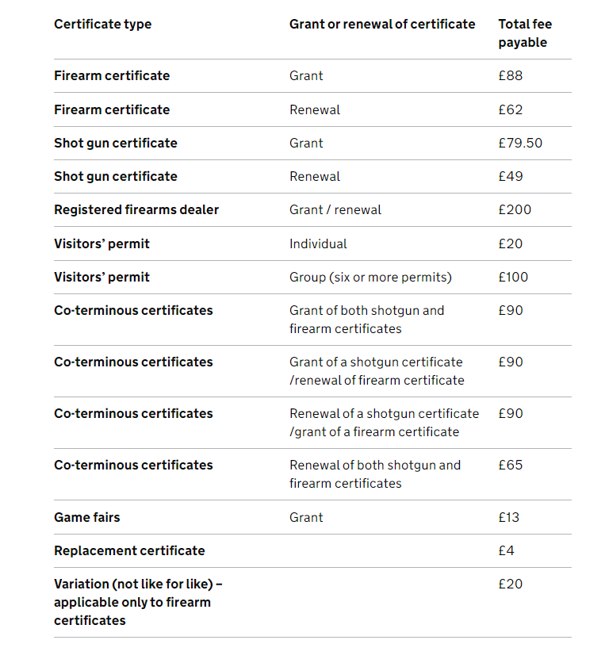

CHEQUES/ POSTAL ORDERS MADE PAYABLE TO PCC LANCASHIRE

DEBIT/CREDIT CARD PAYMENTS ARE ACCEPTED
(Please indicate on your application you wish to pay by card)

THERE ARE NO FEES FOR THE FOLLOWING

Change of Address
Section 11(6)
Club Firearm Certificate

